**Additional Desktops**

There are 2 separate desktops contained in the default setup.  Each desktop can be customized with its own icons, background, and separate name.  All features are the same on both displays.  You can also add up to an additional 6 desktops, or remove up to all but 1 desktop.

**Desktop Shortcut:** Each desktop present is represented by a white, blue-outlined circle displayed near the bottom of the screen.  The circle representing the desktop currently on the screen will be filled in blue instead of white.  The shortcuts allows you to switch between your various desktops.



* **To switch desktops**, click on the circle that represents the desired desktop. The program will switch to that desktop and the selected circle will turn blue.
* **To go back to the previous desktop**, click on the circle that represents it.  The program will then switch back to the previous desktop.
* **To change the order of the desktops**, see the “Desktop” topic under “Settings.”

**Adding Desktops:** To add a new desktop, click the  icon to the right of the Desktop Shortcuts. The following window will appear:

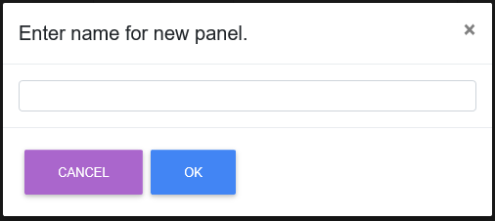

Type in a name for the new desktop and click **OK**. The program will open a new desktop with your desired name, and a new shortcut circle will appear at the bottom of the screen. **NOTE:** You will not be able to rename the desktop after creating it.

**Removing Desktops:** To remove a desktop from the program, click on the black “X” next to the desktop’s name:



The following window will open:

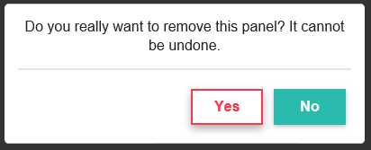

Click **Yes** to remove the desktop. The shortcut circle representing the desktop will disappear and the program will automatically switch to a different desktop.

**NOTE:** For an alternate method of removing desktops, see the “Desktop” topic under “**Settings**.”